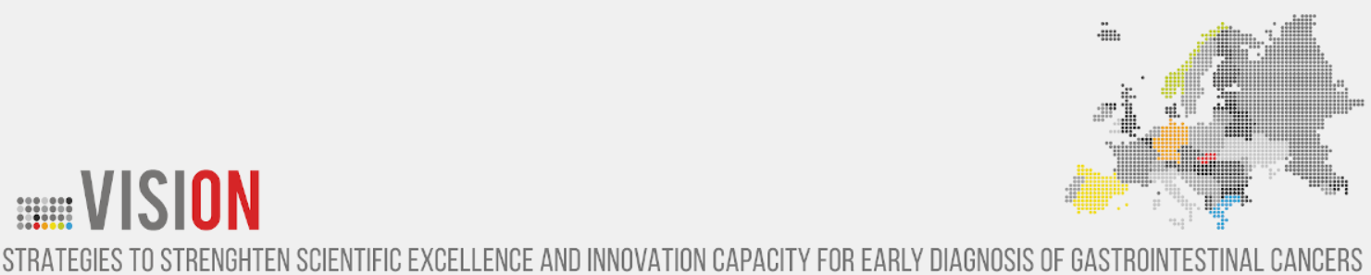

COURSE OUTLINE

Course title | Statistical Analysis of Biomedical Data: Basic Principles and Practicals
Lecturer | Marilena Anastasaki, MSc (Biostatistics), PhD candidate
Course type | Online lectures (theory and practice using the SPSS statistical package)
Duration | 30 hours (divided into 10 three-hour lectures)
Course dates | 4 – 15 October 2021 (lectures) and  18 – 29 October 2021 (AOB including supplementary courses, individual communications, or revision courses based on the audience needs)
Course time | 15.00 – 18.00 CET
Course language | English
Learning objectives | The course aims to provide participants with a basic understanding of terms and methods of statistical data analysis, with a specific focus on practical exercise and familiarization with statistical applications in biomedical research.
General skills | - Adjustment  - Decision making  - Individual work  - Teamwork  - Critical thinking  - Promotion of free, creative, and inductive thinking  - Data/evidence review, analysis, and synthesis using technology
Course outline | - Descriptive Statistics  - Variables and data types  - Central tendency and variance indicators  - Distributions and graphs  - Introduction to SPSS: variable entry and coding, data entry and management  - Ιnferential Statistics  - Population and sample  - Confidence intervals and hypothesis testing  - Univariate analysis (X² test, Student’s t-test, Mann-Whitney test, one-way ANOVA, Kruskal-Wallis test, Pearson and Spearman correlation coefficients, Paired t-test, Wilcoxon sign rank test, ANOVA for repeated measurements)  - Linear regression (simple and multiple linear regression, model interpretation)  - Logistic regression (hypothesis testing and model fitting, interpretation of model coefficients)  - Survival analysis  - SPSS practicals
References | - James F Jekel, Joann G. Elmore, David L. Katz. Epidemiology, Biostatistics, and Preventive Medicine. Yale University, New Haven, CT, 1996  - Nigel Bruce, Daniel Pope, Debbi Stanistreet. Quantitative Methods for Health Research. A Practical Interactive Guide to Epidemiology and Statistics. Wiley, 2018
Requirements | Download the free 30-day SPSS trial version: https://www.ibm.com/analytics/spss-trials

